OSI MODEL
1. Stratified architecture
- Layered architecture in a network is a way of designing a communication system by dividing the entire communication process into many independent layers. Each floor assumes a clear role and only interacts with the layers adjacent to it.
Stratified architecture was born to solve three core problems:
- Too complicated to manage
- There is no common standard for communication
- Expandable and maintainable
Thanks to stratification, computer networks can develop into the global Internet as it is today.

General Stratification Architecture Model:
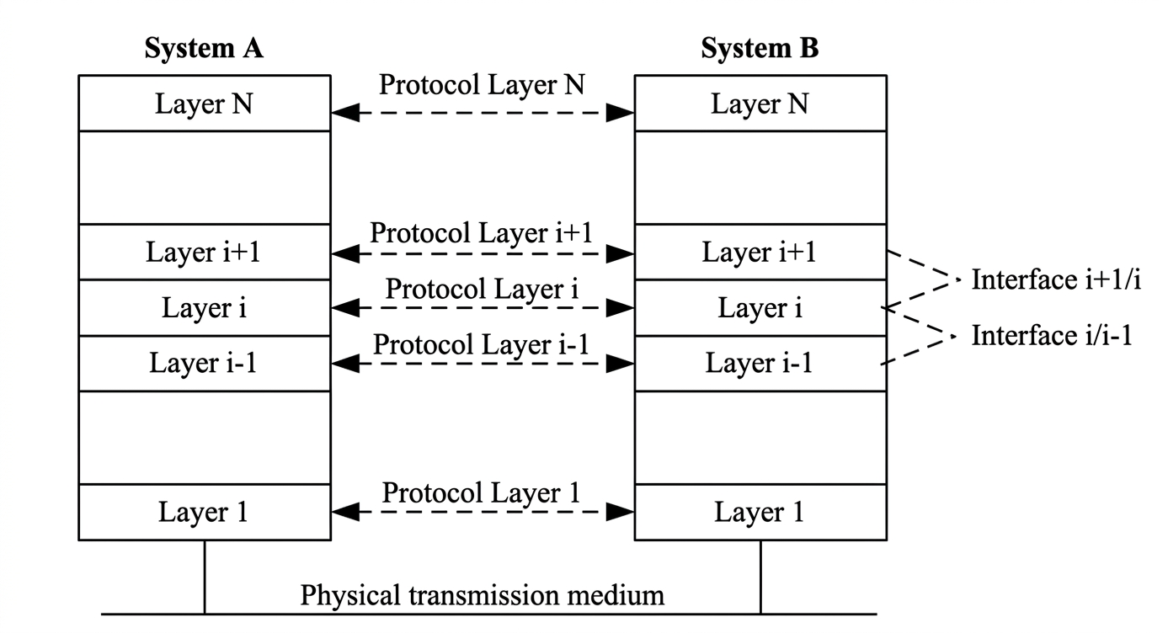
The image depicts how two systems A and B communicate with each other in layers
2.What is the OSI model?
- The OSI (Open Systems Interconnection) model is a standard reference framework developed by the ISO (International Organization for Standardization) in 1984. This model describes how data is transmitted over a network by dividing the communication process into 7 separate layers, each of which assumes a specific function and is independent of each other.

OSI Model Design Principles
- Each floor performs a well-defined set of functions.
- Each floor only communicates with the adjacent upper and lower floors.
- The number of floors is enough to group similar functions, but not so many that they are complex.
- Boundaries between floors are defined to minimize the flow of information back and forth.
- Each floor can be changed internally without affecting the other, as long as the interface remains constant.

2.1. DATA PACKAGING AND UNPACKING PROCESS
When an application sends data over the network, it must pass through all 7 layers of the OSI model in a top-down direction on the sending side, and backwards from the bottom up on the receiver side. This process is called encapsulation and decapsulation.
3. 7-TIER OVERVIEW OF OSI MODEL
The OSI model consists of 7 tiers numbered from 1 (lowest - near hardware) to 7 (highest - near the user). When transmitted, data travels from layer 7 to layer 1 on the sending side, and vice versa from layer 1 to layer 7 on the receiving side.
Floor | Name (English) | Main Functions | Data Units | Protocols/Examples | Related Equipment
7 | Application | Communicate directly with the user app | Data | HTTP, FTP, SMTP, DNS | Browser, server
6 | Presentation | Convert formats, encode, compress data | Data | SSL/TLS, JPEG, MP3 | Usually software
5 | Session | Establish, maintain, and end work sessions | Data | NetBIOS, RPC | Operating System
4 | Transport | End-to-end data transmission, error control, data fragmentation | Segment | TCP, UDP | Firewall, Load Balancer
3 | Network | Routing, routing by IP | Packet | IP, ICMP, Routing (OSPF, BGP) | Router
2 | Data Link | Frame packing, error checking, MAC address | Frame | Ethernet, ARP, PPP | Switch
1 | Physical | Passing Bits Through Physical Environment | Bit | Cables, electrical signals, waves | Hub, network cable
4. DETAILS OF EACH FLOOR OPERATION
4.1. Layer 7 – Application Layer
- The Application layer is the highest layer and closest to the user in the OSI model. This is the layer that provides network services directly to that application.
- Key functions: identify and validate communication partners, check resource availability, synchronize communication applications, and establish agreements on error recovery processes.
Example : - Enter the URL https://google.com
-client tạo 1 request :

GET /search?q=chatgpt HTTP/1.1
Host: google.com

-Sever answers:

HTTP/1.1 200 OK
Content-Type: text/html

<html>... </html>

-The 7th floor is where requests are made, nothing has been done, protocol definitions, and communication content is created

4.2. Floor 6 – Presentation Layer
- This layer on the data transfer computer is responsible for translating data sent from the application layer to the common format.

-Main Functions:
+ Convert between character encoding standards such as ASCII, EBCDIC, Unicode
+ Data compression to reduce the amount of data transmitted on the network.
+ Encrypt and decrypt data to ensure security on the network.

Examples of normalizing characters
Suppose layer 7 generates data:

GET /search?q=Google HTTP/1.1

On machine A (using ASCII)
The letter "G" is saved:
ASCII: 71 (decimal) = 01000111 (binary)

On machine B (using EBCDIC)
The "G" is:
EBCDIC: 199 (decimal) = 11000111

-2 machines will not understand each other because of binary mistranslation, so (machine A will ASCII → UTF-8)
(UTF-8 B machine → EBCDIC)

For example:
-NORMAL HTTP
"GET /search?q=chatgpt HTTP/1.1"
↓
01000111 01000101 01010100 ...

-Layer 6 Convert strings to binary (UTF-8) = >normalize data for transmission

-https
GET /search?q=chatgpt HTTP/1.1Host: google.com
↓ Coded into:
A9 F3 7B 22 98 11 ...
-Data compression
<html>... </html>↓(binary compressed)
-If receiving the process will reverse decrypt, decompress, decode
4.3. Floor 5 – Session Layer
- The Session layer manages the establishment, maintenance, and termination of sessions between two applications
-. A session is an ordered and synchronized conversation between two terminals.
Example: Website Login
-Client Submit
POST /login
username=abc&password=123
Creation Server:
Session ID = XYZ123
http send inbound
Set-Cookie: session=XYZ123
With 1 click on any
GET /profile
Cookie: session=XYZ123
-The 5th floor will understand that you are with 1 person, maintain that session without having to log in again

In addition to session ID, the 5th floor also:
-Synchronization (đồng bộ):
If the data transfer is large: set the check point so that the load can resume if the data is lost
-Dialog control:
Who sends first (half-duplex / full-duplex) (client or server sends data first / server and client send data together)
-Session recovery:
Loss of network → session restoration

4.4. 4th Floor – Transport Layer
- The Transport layer is the center of the entire OSI model. It provides end-to-end reliable communication between two applications.
- The Transport layer performs data segmentation — dividing large data from the Session layer into smaller segments for more efficient transmission, and reassembling it at the receiving end.
For example:
Establish a connection (TCP handshake)
Before sending data, TCP must make a connection:
Client→SYN→ServerClient←SYN-ACK←ServerClient → ACK → Server
-Then, the next step is to break down the data:
A 10MB file → divided into several small parts:
Package 1 Pack 2 Pack 3...

4.5. Layer 3 – Network Layer
- The Network layer is responsible for routing packets from source to destination over various networks. It is the only layer that understands IP addresses and global network topology.

-Main Functions:
+ Routing: determines the optimal path for packets through intermediary routers
+ Logical Address (IP): attach the source and destination IP addresses to each packet
+ Fragmentation: splitting the packet if the size exceeds the MTU of the transmission line

Example: Sending packets from machine A (192.168.1.10) to server (142.250.66.14)

- Layer 3 packs more IP headers to the Segment received from Layer 4:

[Segment from the 4th floor]
↓
IP Header | Segment
Source IP : 192.168.1.10
Dest IP : 142.250.66.14
TTL : 64
Protocol : 6 (TCP)

Router 1 receives packets → reads Dest IP → checks routing tables:
142.250.66.0/24 → via 10.0.0.1 (next-hop gateway)
→ forward packets to Router 2 →... → to the destination server

-Layer 3 doesn't care about the internal data, only reads the IP header to decide on forwarding

4.6. Layer 2 – Data Link Layer
- The Data Link layer encapsulates packets into frames and passes through a single physical link between two adjacent devices (node-to-node). This layer uses MAC addresses instead of IP addresses to identify devices in the same segment of the network.

-Main Functions:
+ Frame packaging: add MAC header (6 bytes src + 6 bytes dest) and FCS trailer to the package
+ MAC address: physical, globally unique (48-bit) network card identification
+ Error checking: using CRC (Cyclic Redundancy Check) to detect errors that occur when transmitting

Example: Sending frames in the intranet via a switch

- Layer 2 packs more MAC headers into the Packet received from Layer 3:

[Packet from the 3rd floor]
↓
MAC Dest : AA:BB:CC:DD:EE:FF (MAC of router/gateway)
MAC Src : 11:22:33:44:55:66 (MAC of machine A)
EtherType : 0x0800 (IPv4)
| Packet |
FCS: A3 7F B2 C1 (4 byte CRC error check)

MAC Dest reading switch → check the CAM panel → transfer the frame to the correct port

-Every time a packet passes through 1 router: MAC Dest and MAC Src are updated again, while the source/destination IP remains the same

4.7. Floor 1 – Physical Layer
- The Physical layer is the lowest layer, which is responsible for transmitting the raw bits (0 and 1) through the physical environment. This layer is not interested in the meaning of the bits, only the physical mechanism for transmitting them.

-Main Functions:
+ Convert bits into physical signals: voltage (copper cable), light (fiber optic), radio waves (Wi-Fi)
+ Bit synchronization: ensure that the receiver reads each bit correctly at the right time
+ Determine the bit rate and transmission mode: simplex / half-duplex / full-duplex

Example: Frame transfer over Ethernet cable (UTP Cat5e)

- Layer 2 pushes the frame to the 1st floor in the form of a string of bits:

Frame : 01001000 01100101 01101100 01101100 01101111 ...

Layer 1 converts each bit into an electrical signal:
1 bit → high voltage (+5V)
Bit 0 → low voltage (0V)

↓ Transmission through copper wires as electrical impulses

_____¯¯¯¯¯_____¯¯¯¯¯¯¯¯¯¯¯_____
0 1 1 0 1 1 1 0

-The receiver reads the electrical signal → converts it back into a bit → pushes it to the 2nd floor

